give fulll circuit connections with pins
Here is your complete circuit connection documentation for the Smart Diabetic Foot Ulcer Monitoring System (Both Shoes – ESP32 + FSR + Temperature Sensor). You can directly include this in your Hardware / Implementation chapter.

FULL CIRCUIT CONNECTIONS WITH PIN DETAILS
1. Components Used
- ESP32 (2 units – Left & Right Shoe)
- FSR Sensors (4 per shoe → total 8)
- Resistors (4.7kΩ × 8)
- DS18B20 Temperature Sensor (2)
- 4.7kΩ pull-up resistor (for DS18B20)
- Jumper wires
- Power supply (3.3V from ESP32)

2. FSR SENSOR CONNECTION (FOR ONE SHOE)
FSR Working Circuit (Voltage Divider)

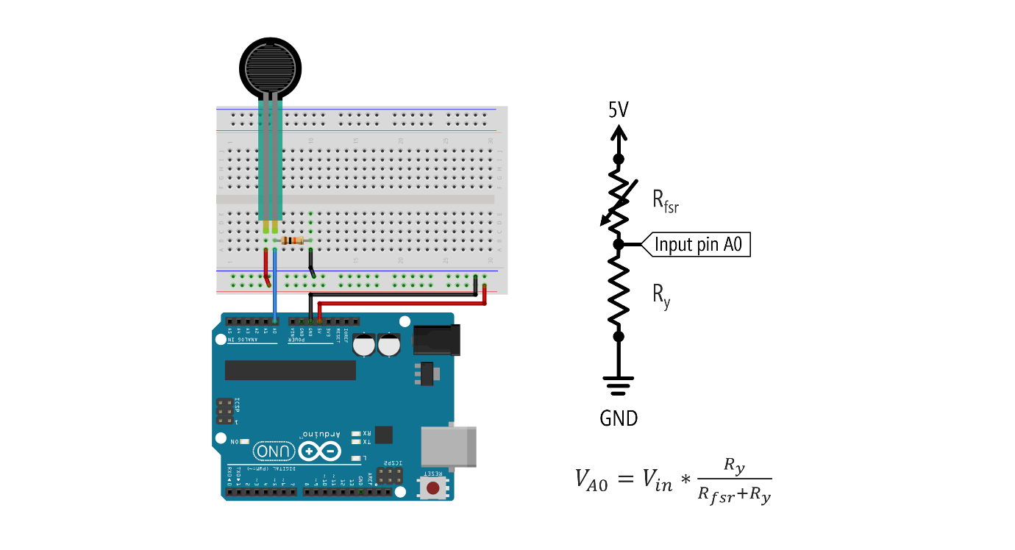
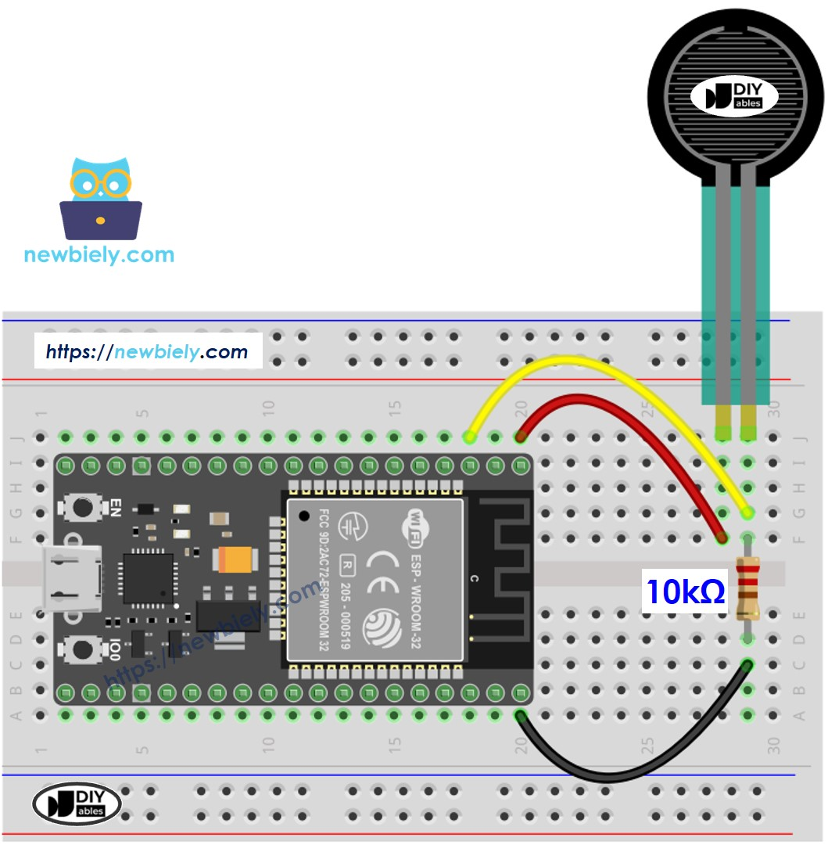
4
Connection Explanation
Each FSR must be connected using a voltage divider circuit.
General Connection Formula
3.3V ---- FSR ---- Analog Pin ---- 4.7kΩ ---- GND

LEFT SHOE – FSR PIN CONNECTIONS
Sensor Position | ESP32 Pin | Connection
Heel | GPIO 32 | Analog Input
Midfoot | GPIO 33 | Analog Input
Ball | GPIO 34 | Analog Input
Toe | GPIO 35 | Analog Input

RIGHT SHOE – FSR PIN CONNECTIONS
Sensor Position | ESP32 Pin | Connection
Heel | GPIO 35 | Analog Input
Midfoot | GPIO 33 | Analog Input
Ball | GPIO 34 | Analog Input
Toe | GPIO 32 | Analog Input

3. DS18B20 TEMPERATURE SENSOR CONNECTION
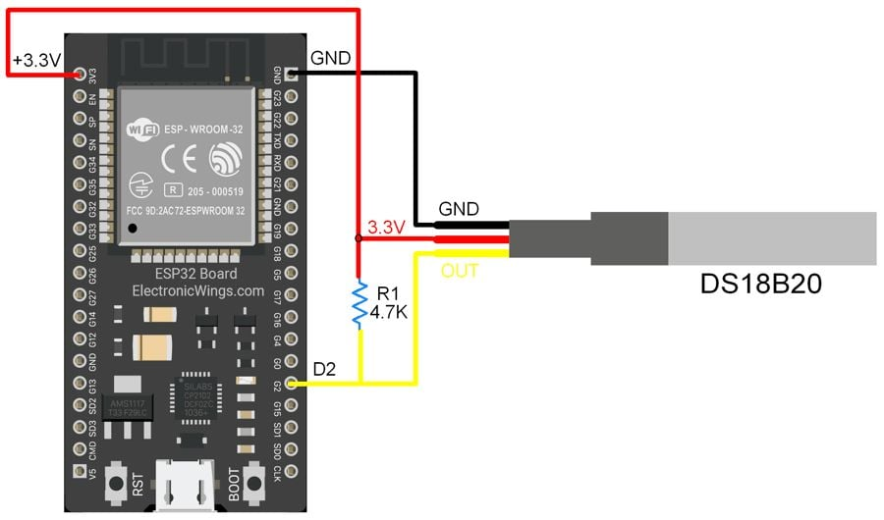

Pin Configuration of DS18B20
DS18B20 Pin | Connection
VCC | 3.3V
GND | GND
DATA | GPIO 25

Important
- Add 4.7kΩ resistor between DATA and VCC
- This is required for OneWire communication

4. POWER CONNECTIONS
Component | Connection
ESP32 | USB / Battery
FSR Sensors | 3.3V
DS18B20 | 3.3V

5. COMPLETE CONNECTION SUMMARY (ONE SHOE)
ESP32 Pins Used
Function | Pin
FSR Heel | GPIO 32
FSR Midfoot | GPIO 33
FSR Ball | GPIO 34
FSR Toe | GPIO 35
Temperature Sensor | GPIO 25
Power | 3.3V
Ground | GND

6. BOTH SHOES ARCHITECTURE

4
System Flow
LEFT SHOE ESP32 → WiFi → Python Server
RIGHT SHOE ESP32 → WiFi → Python Server

7. IMPORTANT PRACTICAL NOTES
✔ Use ADC Pins Only
- GPIO 32, 33, 34, 35 are analog pins
- Do NOT use digital-only pins

✔ Common Ground Required
- All sensors must share same GND

✔ Stable Readings Tip
- Use 4.7kΩ resistor (not 10kΩ)
- This improves sensitivity

✔ Avoid Floating Values
- Always use proper resistor
- Loose wiring causes random values

8. FINAL CONNECTION DIAGRAM (TEXT FORMAT)
FSR (each sensor):
3.3V → FSR → ESP32 Analog Pin → 4.7kΩ → GND
DS18B20:
VCC → 3.3V
GND → GND
DATA → GPIO 25
(4.7kΩ between DATA & VCC)

Conclusion
This circuit setup enables:
- Accurate foot pressure sensing
- Reliable skin temperature measurement
- Stable data transmission via ESP32 WiFi

